|  |  |  |
| --- | --- | --- |
|  |  | project proposal |

1/18/2017

# From:

Roland Abrahantes and David Guevara

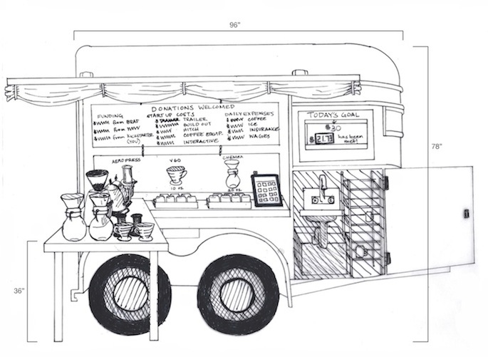

## Prepared For:

Dr. Gunay GGC

INTORDUCTION

1. Introduction

* What's new?

*Brew Coffee Company* is a locally owned family business.  It is a startup with an idea to cater third wave coffee in a mobile cart.  This takes the Food Truck idea to another level.  The idea here is to provide a mobile application that acts as a "Rewards Program".  Where customers can download the app, create an account; use it every time they make a purchase to keep track of their reward points.  After so many points, they can cash the points in for a free drink, etc.

App can also provide a tab for the drinks Menu, a tab for "Locations" which will show either a list of upcoming events where Brew Coffee will be present or a calendar view.  For more information on the company and/or business culture please refer to www.BrewCoffee.Company

* Why is this a good project?

Due to the Mobile business model, it is uncertain when and where you can get Brew Coffee again.  This will help customer’s stay connected and look for upcoming events. It also encourages customers to make purchases in hopes of redeeming their purchases for rewards.  Lastly, as a business owner this will help gather customer’s contact information and make a great tool to send offers and notifications.

* Brief list of requirements/features/issues/risks, including priorities and justifications

Requirements: app to be easily downloaded via IOS and Andriod

Features: Login, User Profile, Menu List, Rewards, Upcoming Events. (Social Media login/sharing)??

Issues: Database connectivity. How to authenticate legitimate purchases for rewards.

OBJECTIVES

Our goal is to start a project that meets software quality standards and can be continued past this class.

Customers will be motivated to use this app because it’s a mobile coffee shop coming to you at the click of a button. All done from your mobile phone.

SCHEDULE

We are doing iterations every two weeks to meet schedule demands. Testing will be done as we go and Travis CI will be used as our continuous iteration tool.

* 2/28/2017 -> UI mockup
* 3/15/2017 -> Features and Functionality
* 4/11/2017 -> DB integration

EXECUTION AND METRICS

Activities to reach objectives and goals are defined and carried out, including metrics to gauge the success of activities in reaching the goal or goals. The consultancy engagement services can involve, but not limited to:

* Developing strategy
* Advising and overseeing activities to improve effectiveness and efficiency
* Present and train industry best practices
* Software planning
* Hardware/ software integration
* Design and development services

REVIEW AND CLOSURE

At the end or the engagement term, the success of the engagement will be reviewed and any final sign-off completed. This will include recommendations for future direction for the organization’s IT development and improvement.

TERMS AND AGREEMENT

Length: 3 Months (Spring Semester 2017)

Rate: Free

Billable Hours per Week: 20

RA and DG

Roland Abrahantes and David Guevara

[rabrahantes@ggc.edu](mailto:rabrahantes@ggc.edu)

Georgia Gwinnett College(GGC)